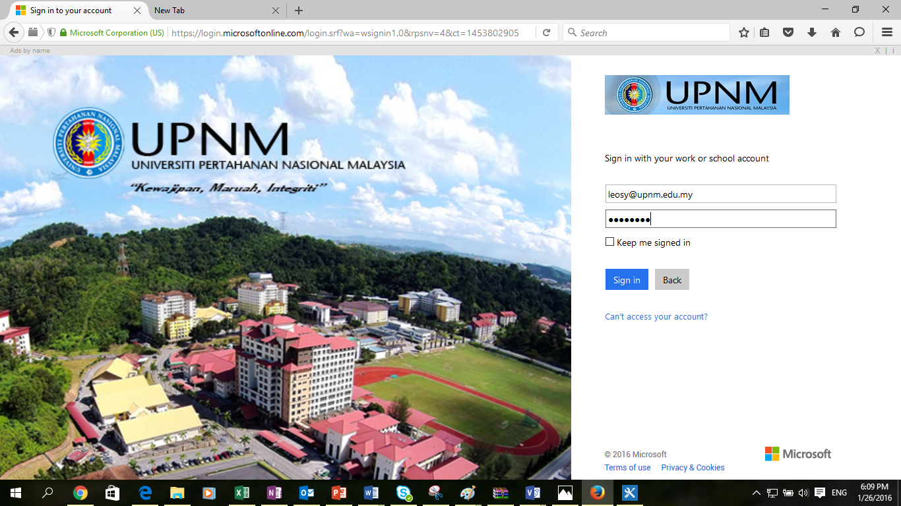

Browse to mail.upnm.edu.my, enter your Login ID and password for accessing your Office 365 services and click **Sign In**.

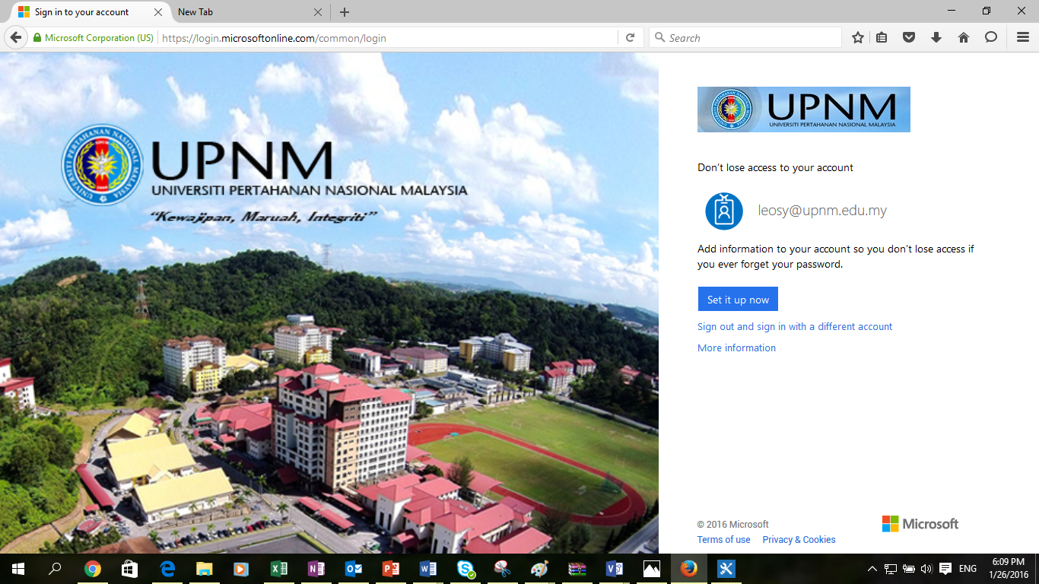

1. Once your successful sign in to Office 365, Don’t lose access your account page is return. Click on **Set it up now** button to enter your alternate email address for self-reset password.

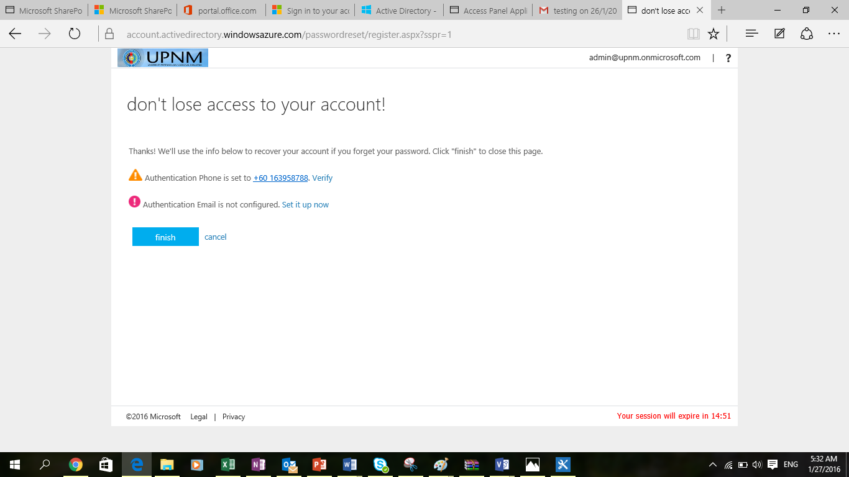

1. Click on the **Set it up now** link beside the Authentication Email is not configured.

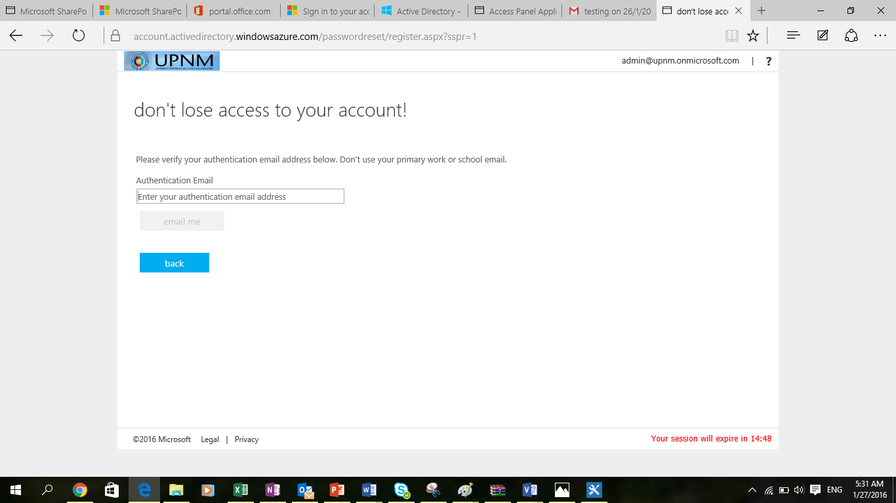

1. Enter your authentication (personal) email address on the text box. Authentication email such gmail.com, hotmail.com, yahoo.com, outlook.com and live.com
2. Click **email me** button.

** Please take note that, you have only 15 mins to provide your authentication email**

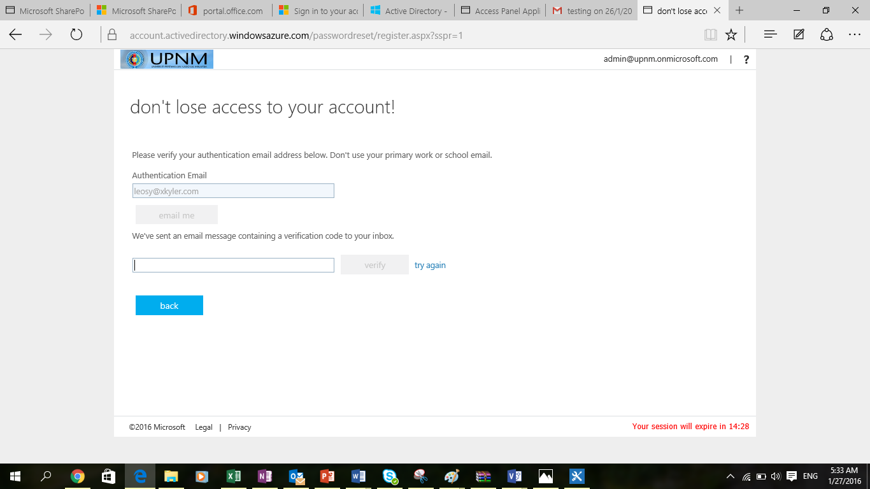

1. Please go to your personal email (the email address that you provide just now) inbox to check an email verification email to verify your email address. 
2. Enter the verification code to the text box and click verify. If Authentication Email is set  then click finish.
3. Now, you will continue to check your email and access Office 365 services.

Any inquiries and questions , please email to [infradc_ict@upnm.edu.my](mailto:infradc_ict@upnm.edu.my)