**Office 365 New User Configuration Guide for Outlook Client**

Version 1.0

Table of Contents

STEP (1) Export Outlook Data file 3

STEP (2) Create new User Profile for Office 365 at Outlook Client Application 8

STEP (3) Import Outlook Data file 18

# STEP (1) Export Outlook Data file

1. Launch Client Outlook 2010 Application
2. Go to **File** > **Open** > **Import** (Import files, settings, and RSS Feeds into Outlook.)

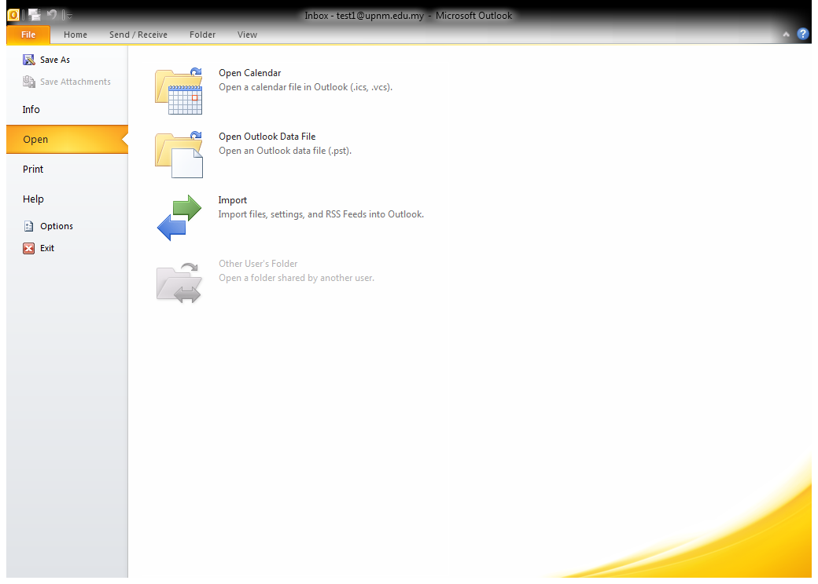

1. In **Import and Export Wizard,** choose **export to a file** and then click **Next.**

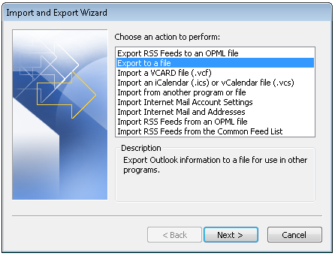

1. From **Export to a File** Wizard, choose **Outlook Data File (.pst)** and then click **Next.**

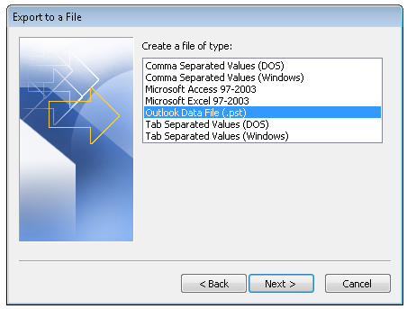

1. In the Export Outlook Data File, on the Select the folder to export from:
2. Click on email address for eg:[**test1@upnm.edu.my**](mailto:test1@upnm.edu.my)above Inbox Item
3. Check **Include Subfolders** checked box and then click **Next**

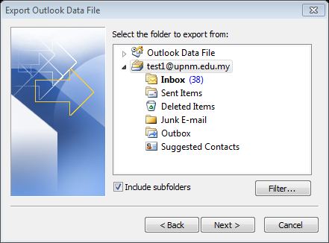

1. Click on **Browse** to search to a location that you would like to Save exported file as:

For eg: **C:\Users\upnm\Documents\Outlook Files\backup.pst**

1. Under Options, choose **Replace duplicates with items exported** and then click **Finish**.

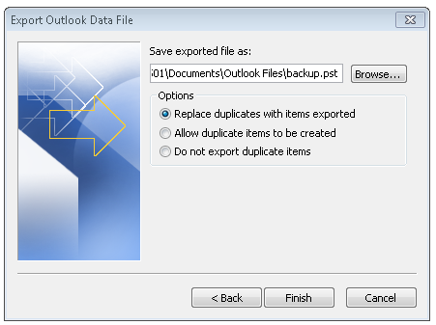

1. In Create Outlook Data File, under Add Optional password, type the password on both Password and Verify Password textbox and then click **OK**

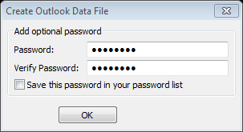

1. Re-type the password for backup on the Password text box for twice (if needed) and then click **OK**.

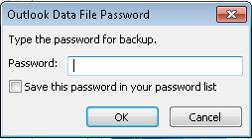

1. You may navigate to the path that you Save exported file as:

For eg: **C:\Users\upnm\Documents\Outlook Files\backup.pst** to confirm the file is save correctly.

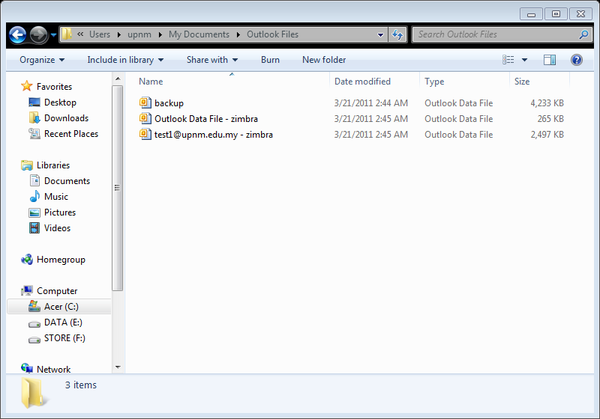

# STEP (2) Create new User Profile for Office 365 at Outlook Client Application

1. Go to **Start >** navigateto **Control Panel** and then click on it

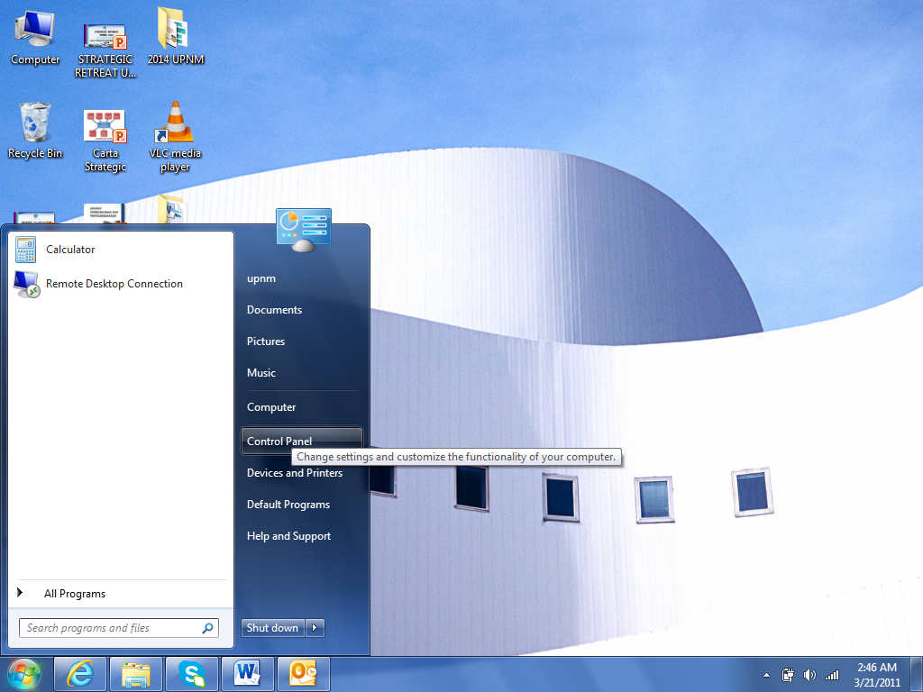

1. Navigate to Mail and click on **Mail**

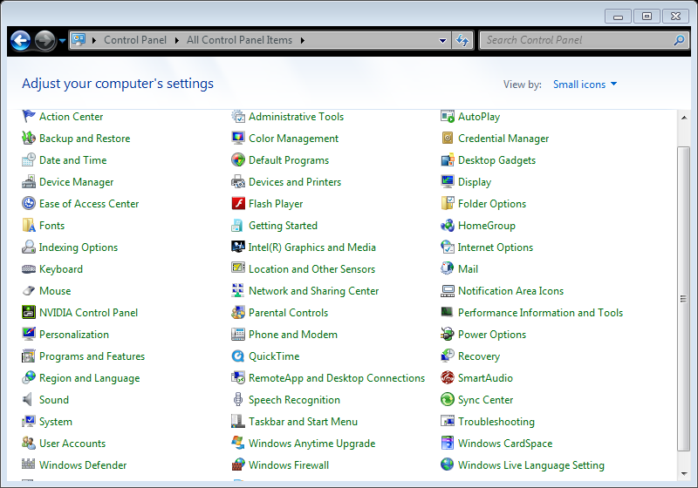

Note: If you have different interface from above screenshot, please change the View by: to **Small icons** for easier view (on the upper right)

1. In Mail Setup, click on **Show Profiles…** button

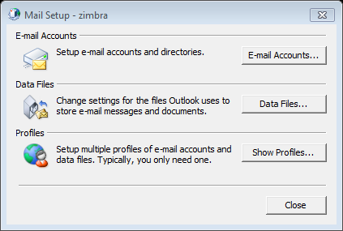

1. In Mail Wizard, under When starting Microsoft Outlook, use this profile:

choose **Prompt for a profile to be used** and thenclick on **Add** button

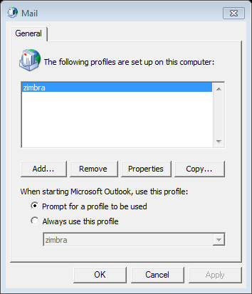

1. Type a name for the Profile Name on the text box and then click **OK**

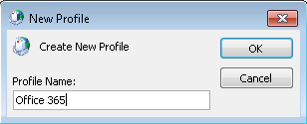

1. In Add New Account, click to select the **manually configure server or additional server** **types** check box, and then click **Next**.

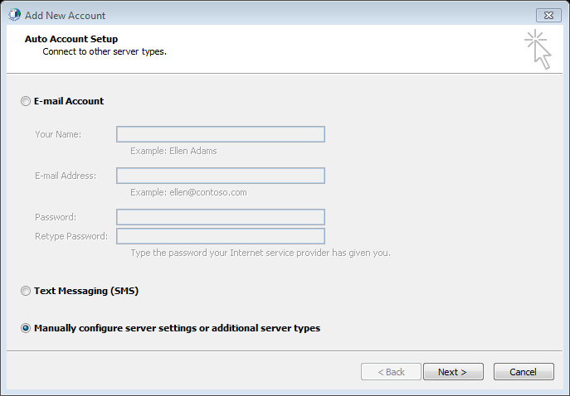

1. Click **Microsoft Exchange or compatible service**, and then click **Next**.

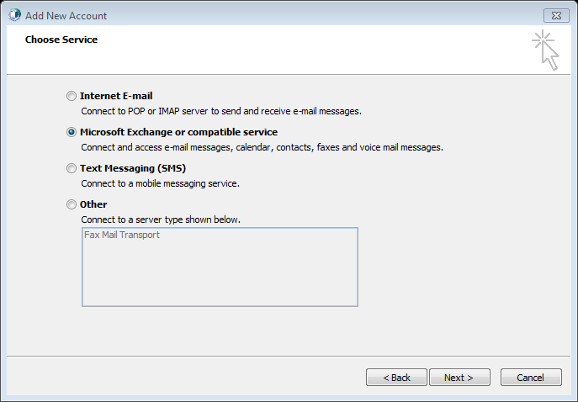

1. In the **Server** box, type the host address (**outlook.office365.com**).
2. Make sure that the **Use Cached Exchange Mode** option is selected.
3. In the **User Name** box, type your user name (for example, [test1@upnm.edu.my](mailto:test1@upnm.edu.my)), and then click **More Settings**.

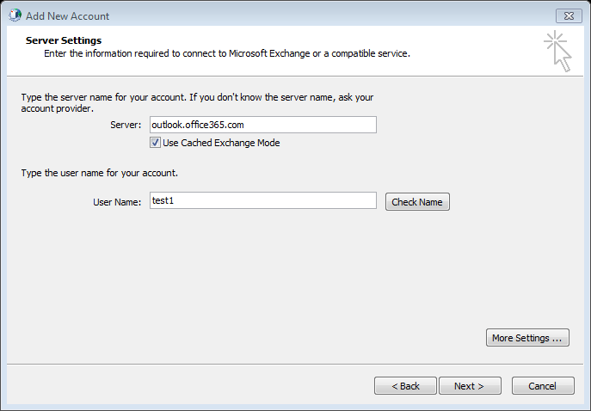

1. Click the **Connection** tab.
2. Make sure that the **Connect to Microsoft Exchange using HTTP** check box is selected, and then click **Exchange Proxy Settings**

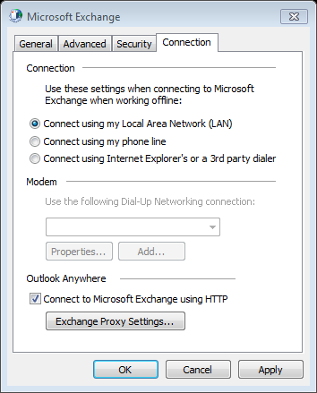

1. In the **Use this URL to connect to my proxy server for Exchange** box, type the host address (**outlook.office365.com**).
2. Make sure that the **Only connect to proxy servers that have this principal name in their certificate** check box is selected, and then type **msstd:outlook.com**.
3. Click to select the **On fast networks, connect using HTTP first, then connect using TCP/IP** check box, and then click to select the **On slow networks, connect using HTTP first, then connect using TCP/IP** check box.
4. Under **Proxy authentication** settings, click **Basic Authentication**.
5. Click **OK**.

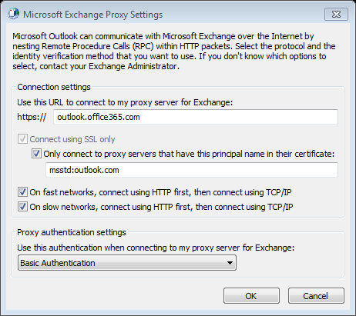

1. Click the **Security** tab.
2. In the **Logon network security** dropdown-list, select **Anonymous Authentication**.
3. Click **OK**.

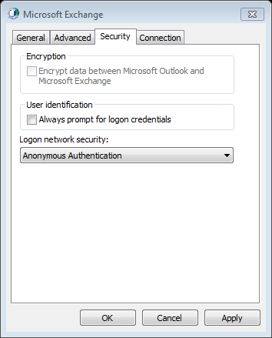

1. Click **Check Names**. When the server name and the user name are displayed with an underline, click **Next**.
2. Windows Security is prompt.
3. Type your user name (for example, [test1@upnm.edu.my](mailto:test1@upnm.edu.my)), and password for Office 365 then click **OK**.

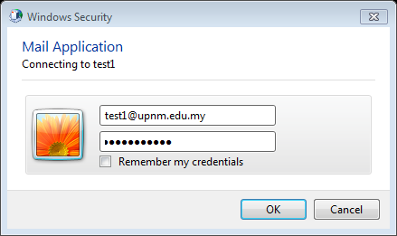

1. You New Profile has been created.

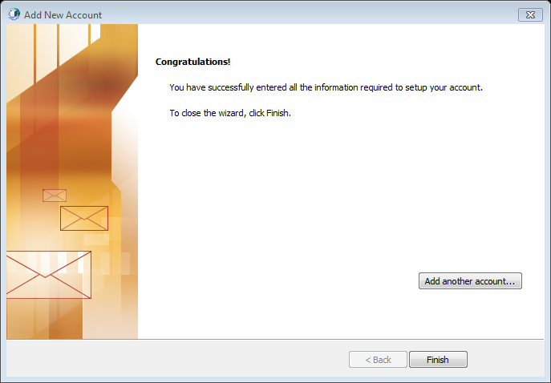

1. Click **Finish**.
2. When launch Client Outlook 2010 Application, the New Profile that you been created will appear at the profile Name. Please click on the drop down list and to choose your new Profile Name and then click **OK**

# STEP (3) Import Outlook Data file

1. Go to **File** > **Open** > **Import** (Import files, settings, and RSS Feeds into Outlook.)

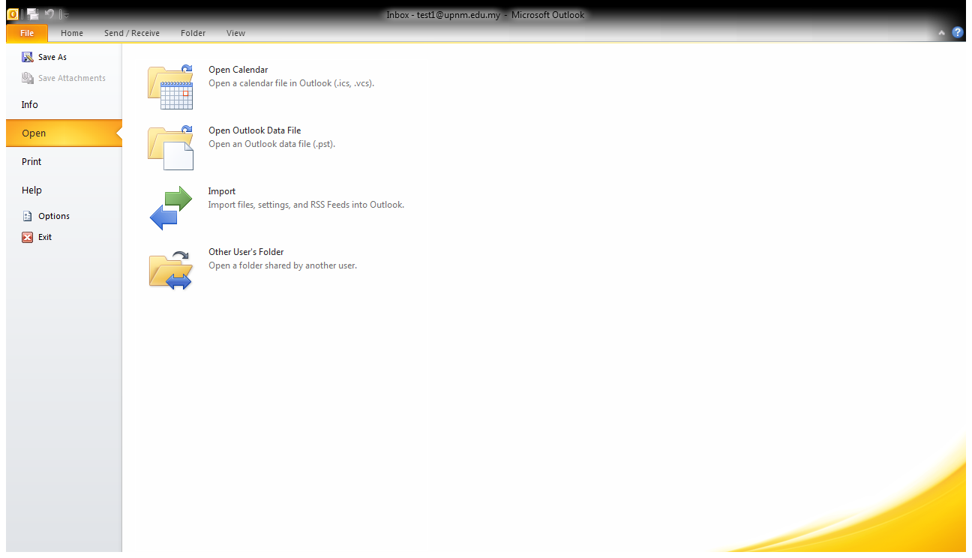

1. In **Import and Export Wizard,** choose **Import from another program and file** and then click **Next.**
2. In Import File, under Select file type to import from: choose **Outlook Data File (.pst)** and then click **Next**

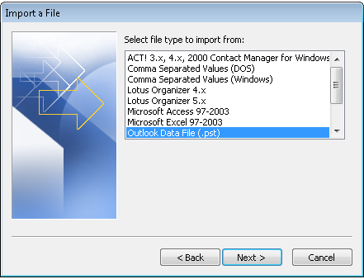

Navigate to the Save exported file as location path: **C:\Users\upnm\Documents\Outlook Files\backup.pst** and then click **OK**

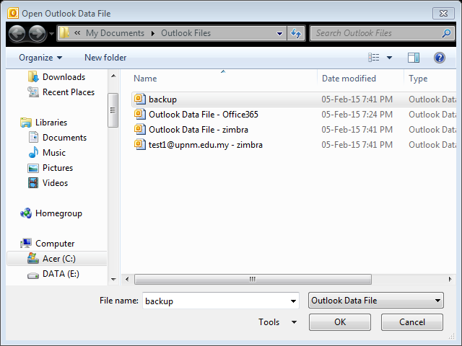

1. Under Options, choose **Replace duplicates with items imported** and then click **Next**

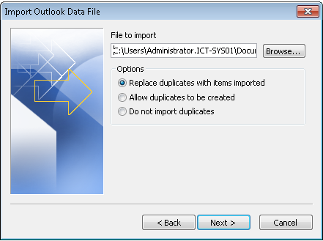

1. In Outlook Data File Password, type the password for backup that you create during export file.



1. Under Select the folder to import from: choose
   1. **Outlook Data File** with checked **Include subfolders** checkbox, choose **Import Items into the same folder in:** > Click **Finish**
2. You are successfully import your zimbra email to Office 365. You can view your zimbra mail through Office 365.

