# Change Temporary Password

For User that Sign in the First Time to change the temporary password to permanent password, please following the instruction below.

1. Browse to Office 365 login page <https://login.microsoftonline.com/> or Office 365 Outlook Web Access page
2. Enter your Office 365 credential as

User ID/email address [xxx@upnm.onmicrosoft.com](mailto:xxx@upnm.onmicrosoft.com) and Temporary password provided by IT administrator

Click “Sign In“button

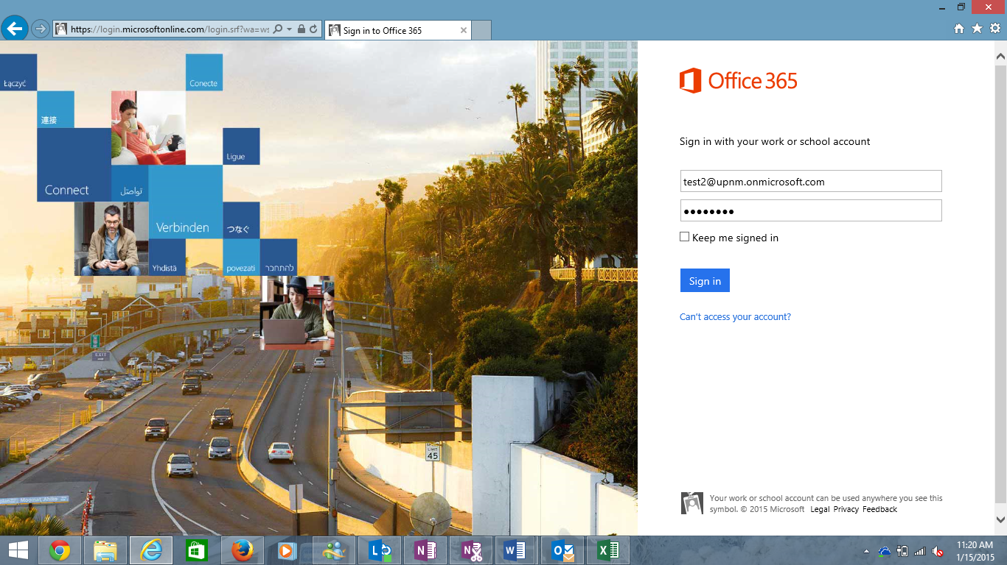

1. You must to update password with re-type the temporary password on the **Old password** textbox and enter your permanent password on the **New password** textbox and **Confirm new password** textbox.

Note: Strong password required. Enter 8-16 characters. Do not include common words or names, combine uppercase letters, lowercase letters, numbers and symbols.

1. Click **Save**.

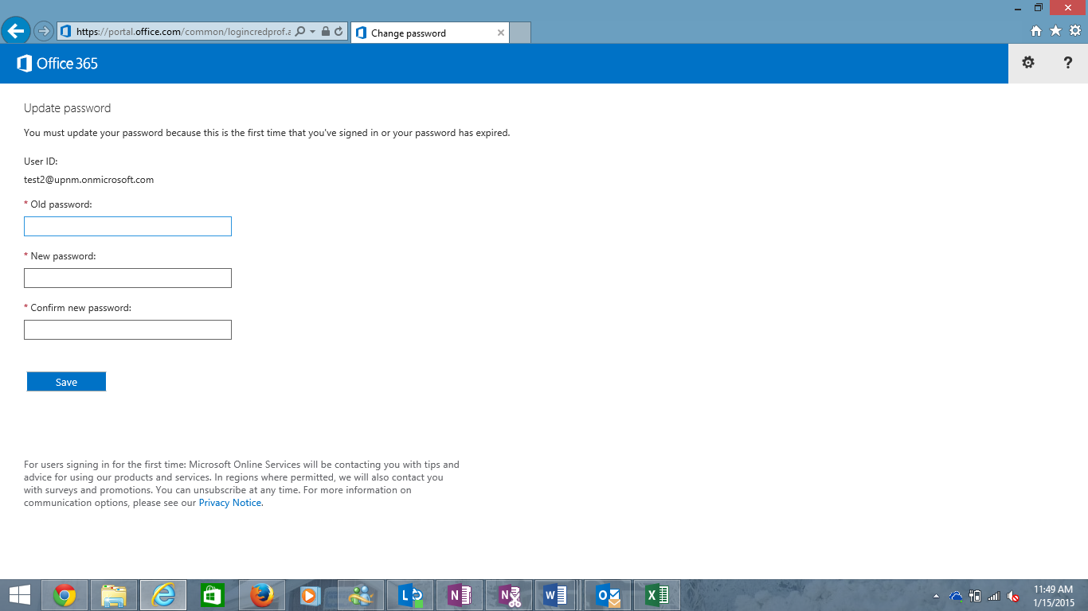

1. After successfully update permanent password and would like to continue use the Outlook and other Office 365 service. Please to re-login with your permanent password that you’ve just update.
2. Click **Sign In**.



Change new password to permanent password

If you would like to change a new password again changed temporary password, please following the instruction as below.

1. Go to Setting  on the upper right.

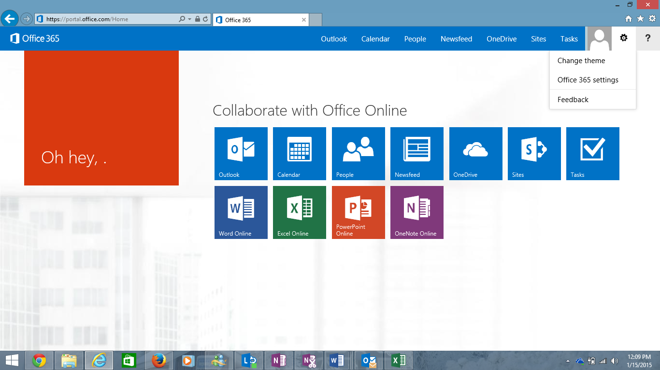

1. Go to Office 365 Setting
2. Click on Password on the left panel.
3. Enter your password on the **Old password** box and enter your new password on the **New password** box and **Confirm new password** box.

Note: Strong password required. Enter 8-16 characters. Do not include common words or names, combine uppercase letters, lowercase letters, numbers and symbols.

1. Click **Save**.

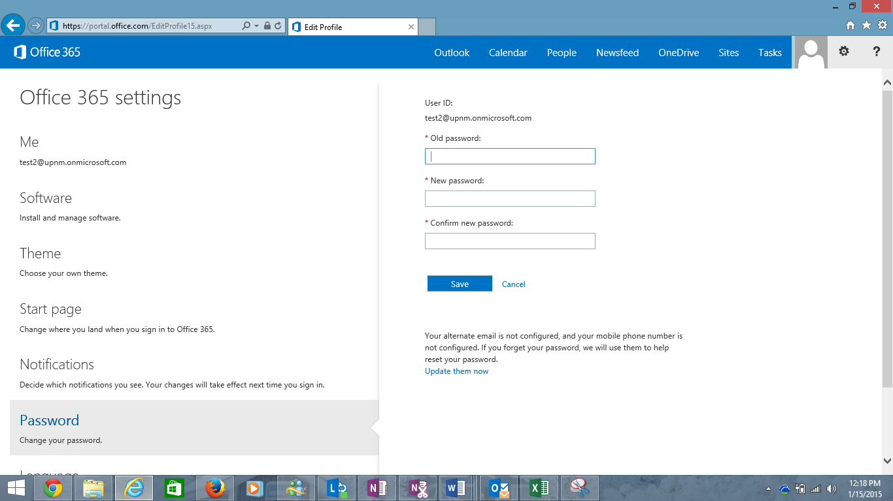

Note: If you forgot your password, please contact Office 365 administrator at [admin@upnm.onmicrosoft.com](mailto:admin@upnm.onmicrosoft.com) for reset password.